CTM-I Test Plan

Menu Tab: Firm Maintenance

Screen: TCP-IP Socket Password

Version 0.1

Menu Tab: Firm Maintenance

Use Case Name | TCP-IP Socket Password
User Roles | Firm User(CTMI_Firm_Options_Root, CTMI_Firm_Options_Admin), Trader(CTMI_Firm_Options_Trader), CBOE User(CTMI_Root, CTMI_Systems, CTMI_Help_Desk)
Pre-conditions /Assumptions | User has successfully logged into the CTM-I application.
Post Conditions | None
Screenshot | 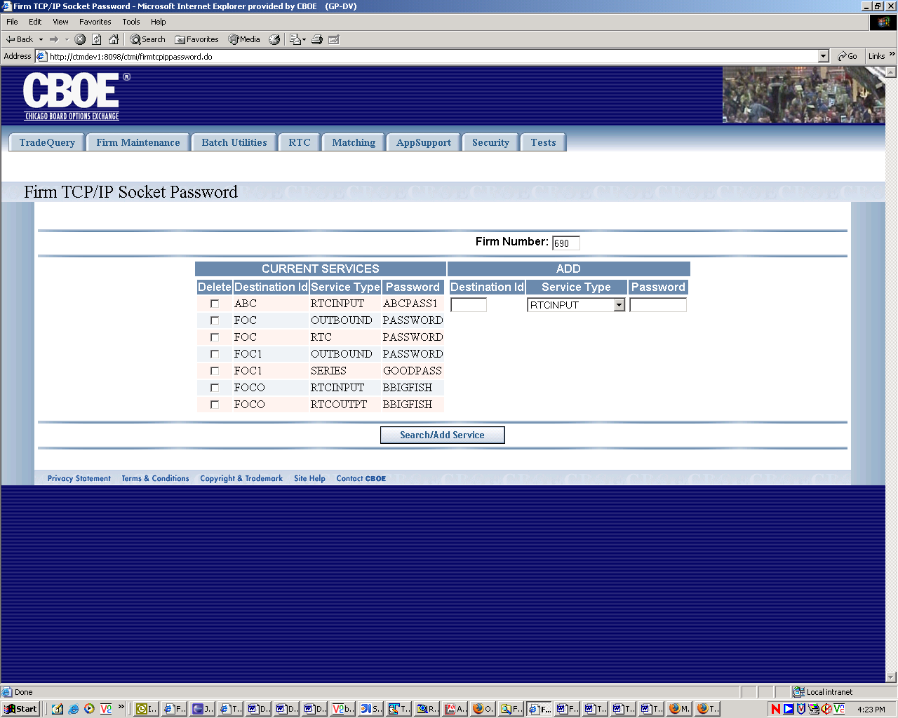
Test Scenario A | User Role : CTMI_Firm_Options_Root, User Id: xxx Password: xxx
 | Action | Expected Out Come | Comments/Results
Test Case 1  Display TCP-IP Password Screen | User Clicks on TCP-IP Socket Password Menu Item | TCP-IP Socket Password Screen displays Destination Id and Password data for the Primary Firm on the Current Services Column and three sets of fields on the Add column. Firm Number field at the top becomes a drop down list populated with all the Primary Firm and Authorized firms for this user. Destination Id field is a drop down field populated with valid destination Id for the firm selected on the firm Number field at the top. This dropdown gets dynamically populated based on the selection of Firm Number at the top. By Default it displays ‘Blank’ entry from the drop down.
Test Case 2  Search | User selects Firm Number in the named field and Clicks Save/Search button. | On ‘Current Services’ Column Screen Displays existing Destination Id, Service Type and Password for the Firm entered in the search criteria with ‘Delete’ checkbox on each row.  On Add Column Destination Its drop down is filled with all valid unique destination Id on the left and defaulted to blank entry selection and Service Type drop down showing default value and Password field remaining blank for user entry in 1 row. If no rows are returned on the left Destination Id Remains unpopulated and remain defaulted to Blank Entry. | If no matching data rows exist no rows are returned.  All rows are returned on the same page. May have to scroll down for large amount of data rows.
Test Case 3  Delete | User Selects destinations to be deleted (Check Box marked). And Clicks Save/Search button | The rows with marked checkbox are deleted. | If ‘Delete’ is successful  Alternate Flow
 |  | Exception/Error Message if Delete Fails | If ‘Delete’ fails  Alternate Flow
Test Case 4  Add | User Selects destination Id and Service Type from drop down list and enters 8 character password in one or more rows on the Add column and Clicks Save/Search button | Destinations with Passwords are added to the database and these new destinations are displayed on the ‘Current Services’ Column. | If additions are successful only. – Alternate Flow
 | User enters a destination Id and Service Type which already exits | Addition fails - Entry Destination for the Service already exists | Alternate Flow
 | User enters a pass word less than 8 char | Addition fails - Invalid Password must be 8 char | Alternate Flow
 | User enters a pass word more than 8 char | Addition fails - Invalid Password must be 8 char | Alternate Flow
 | User Selects Destination Id, and service Type but leaves Password Blank. | Addition fails - Valid Password is required | Alternate low
 | User Selects Blank Destination Id, and service Type and enters 8 character Password. | Addition fails - Valid Destination Id is required | Alternate low
Test Scenario B | Repeat above test cases with login with diff user roles namely Ops(CTMI_Firm_Options_Admin) User Id: xxx Password: xxx
 | Same as in Scenario A
Test Scenario B | Repeat above test cases with login with diff user roles namely Ops(CTMI_Firm_Options_Trader) User Id: xxx Password: xxx
 | Same as in Scenario A
Test Scenario C | Repeat above test cases with login with diff user roles namely AppSupport(CTMI_Root) User Id: xxx Password: xxx
Test Case 1  Display TCP-IP Password Screen | User Clicks on TCP-IP Socket Password Menu Item | TCP-IP Socket Password Screen displays with no data rows on ‘Current Services’ column.. Firm Number field at the top becomes a text box populated with 000. Destination Id field is a drop down field populated with valid destination Id for the firm selected on the firm Number field at the top. This dropdown gets dynamically populated based on the entered of Firm Number at the top. By Default it displays ‘Blank’ entry from the drop down. If entered firm does not have any Destination Id defined Destination Id drop down list is not populated with anything excepting the default blank field.
Test Case 2  Search | User enters Firm Number in the named field and Clicks Save/Search button. | On ‘Current Services’ Column Screen Displays existing Destination Id, Service Type and Password for the Firm entered in the search criteria with ‘Delete’ checkbox on each row.  On Add Column Destination Its drop down is filled with all valid unique destination Id on the left and defaulted to blank entry selection and Service Type drop down showing default value and Password field remaining blank for user entry in 1 row. If no rows are returned on the left Destination Id Remains unpopulated and remain defaulted to Blank Entry. | If no matching data rows exist no rows are returned.  All rows are returned on the same page. May have to scroll down for large amount of data rows.
 | User Enters Invalid Firm numbers like Alpha Characters, more 3 digits etc. | Error Massage is displayed saying Firm Number entered is not valid, please enter numbers up to 3 digits.
 | Remaining Same as in Scenario A
Test Scenario D | Repeat above test cases with login with diff user roles namely  Market Ops(CTMI_Help_Desk), User Id: xxx Password: xxx
 | Same as in Scenario C
Test Scenario E | Repeat above test cases with login with diff user roles namely AppSupport(CTMI_Systems) User Id: xxx Password: xxx
 | Same as in Scenario C

